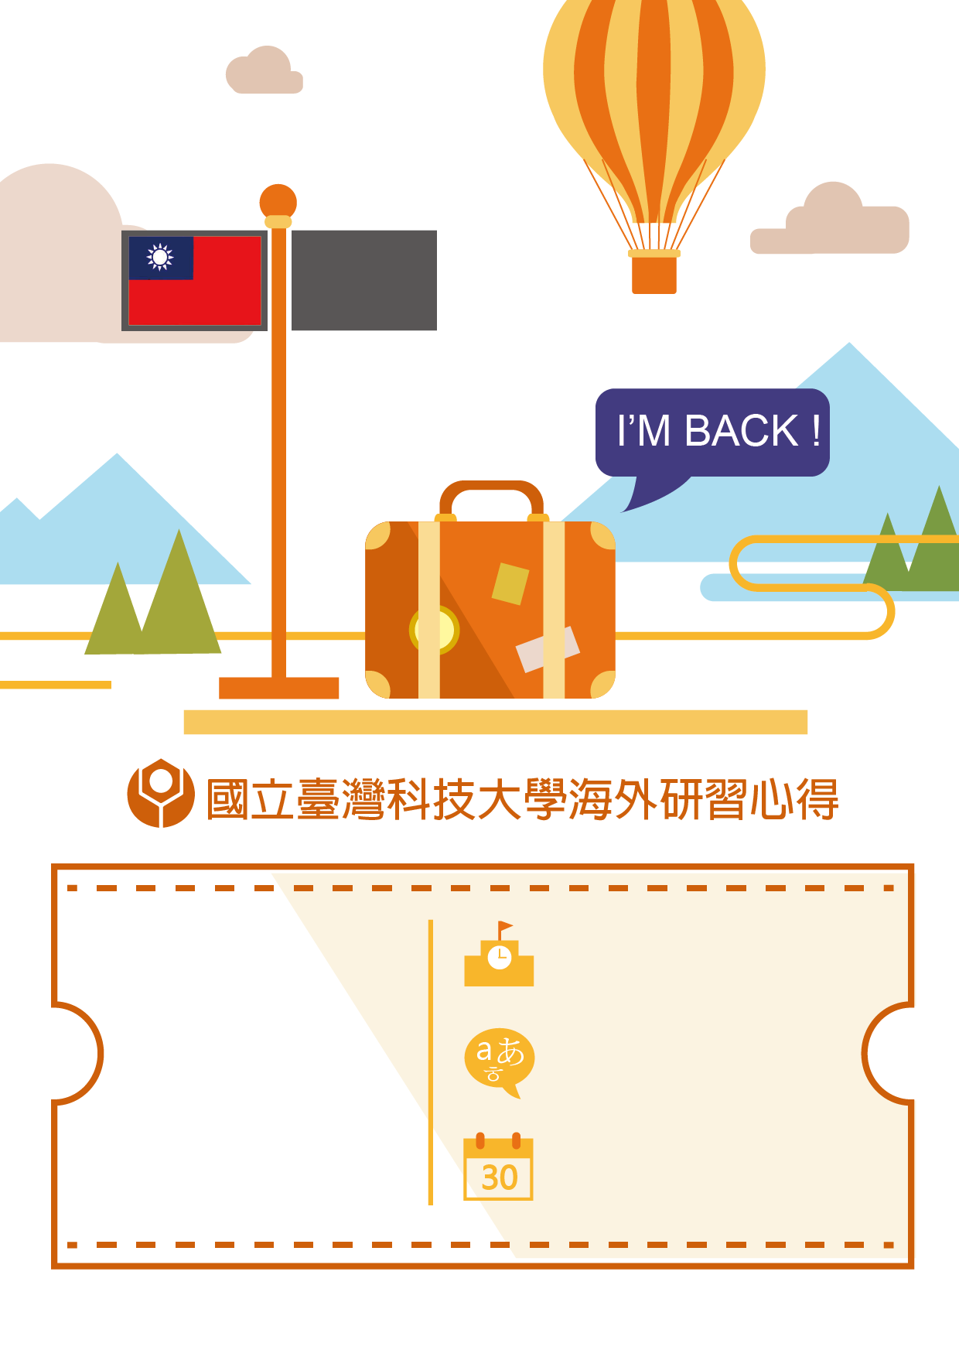

Flag of the host country
Name：
Department：
Student ID：
Semester：
20__/ Fall/ Spring
Host country & university：

Language ：

Exchange period：
yyy/mm/dd~ yyy/mm/dd


Part A (At least 1500 Words)
- Preparation before departure
- Courses take at host universities
- Difficulties and solutions you have during your exchange stay
Part B (200~500 Words)
- Experiences learned and sharing
- Suggestions to potential exchange students
- Picture * 12
- You are free to add more page if you need.
The report shall contain the following sections
(at least 2000 words):

Report:
Part A (At least 1500 Words)
Preparation, Courses and Difficulties you faced
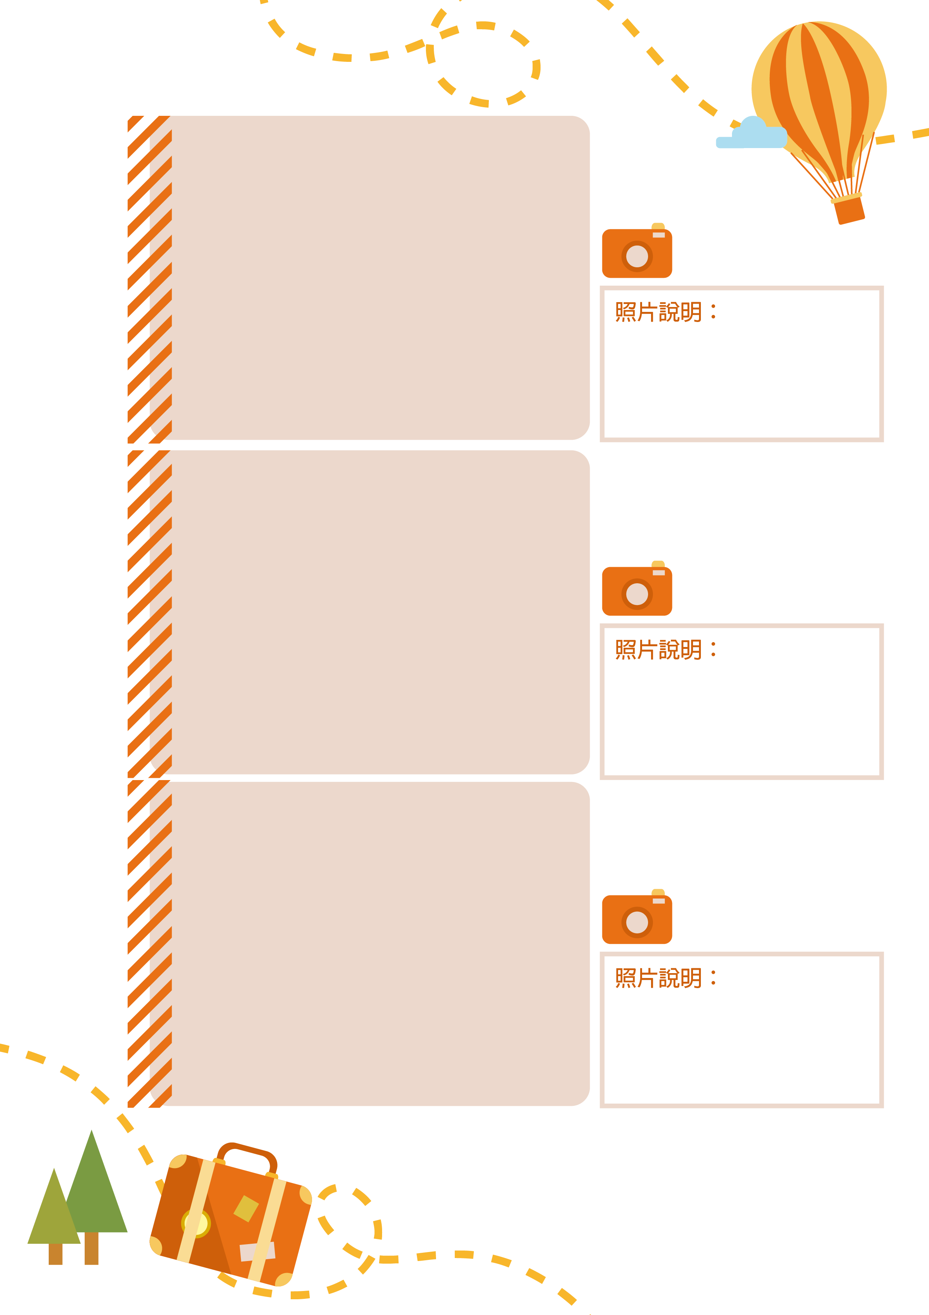
Report:
Report:
Part B (200~500 Words)
Experiences, Suggestions and Picture * 12
Your feedback may be posted on OIA Facebook page in order to share your fruitful experience.
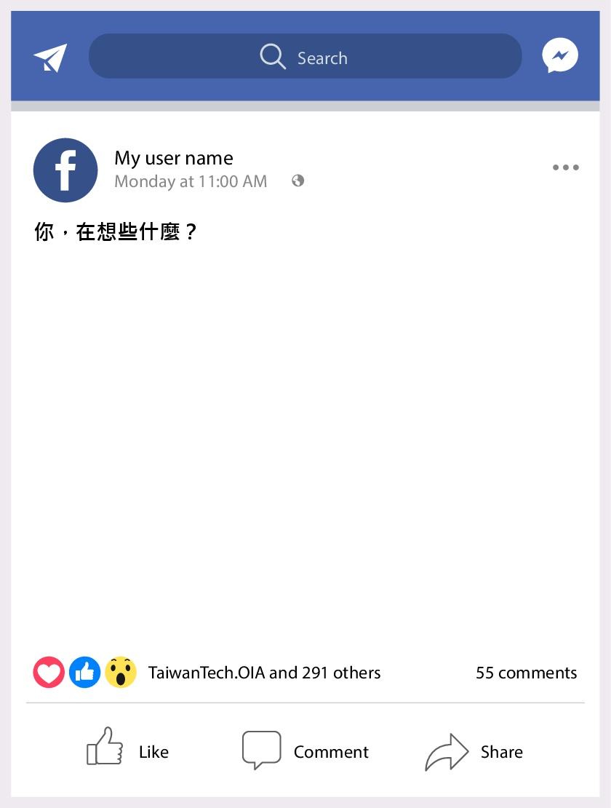
Feedback：
Feedback：

Attach your picture here

Attach your picture here

Attach your picture here

Attach your picture here

Attach your picture here

Attach your picture here

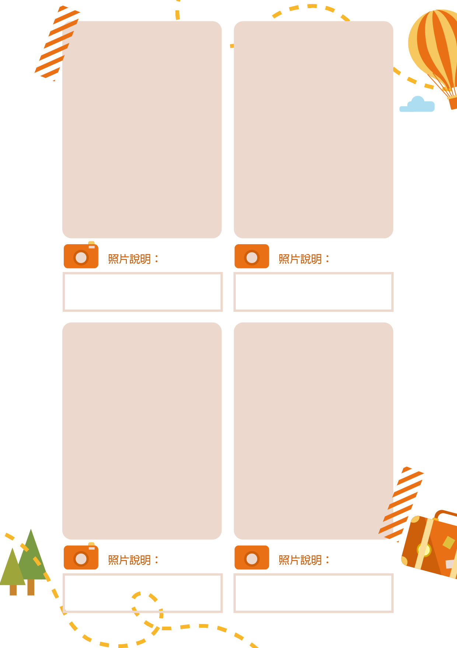
ㄋ

Attach your picture here

Attach your picture here

Attach your picture here

Attach your picture here

